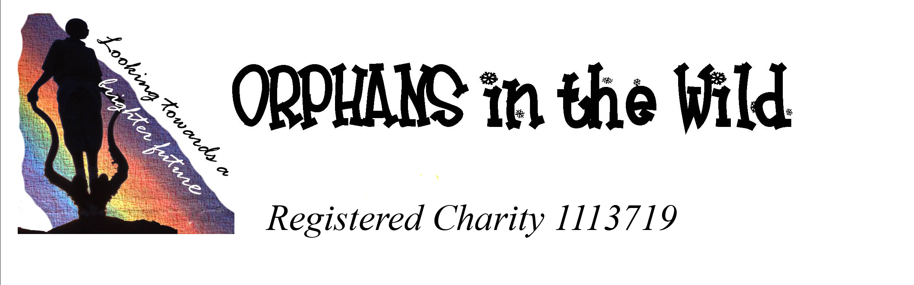

To be able to reclaim tax on your generous donation you must be paying an amount of income tax and/or capital gains tax equal to the tax we reclaim on your donations. So please remember to notify us if you no longer pay an amount of income tax and/or capital gains tax equal to the tax we reclaim on your donation.

If you are happy for us to reclaim the tax, please would you fill in and return the below declaration to:
Rose Marie Cottage, Green St, Brockworth, Gloucester, GL3 4RT.

Gift Aid Declaration.

Name: __________________________

Address: __________________________

__________________________

__________________________

Post Code ____________

I am a UK tax payer and I want Orphans in the Wild to reclaim tax on all donations I make from this date until further notice.

Signed: _____________________________

Date: ________________

